Chapter 11, Problem 32.

Obtain the rms value of the current waveform shown in Fig. 11.63.

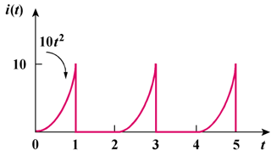

Figure 11.63
For Prob. 11.32.

